- Allwinner A10 or the dual core A20
For Processor Allwinner A10 or the dual core A20, you need to burn the firmware to the micro SD card first, and then use the card to flash the firmware on the tablet Device.
Here is the steps:
- Connect the micro SD card to the PC with card reader.
- Unzip this tool package
- Find this tool and open it: 

- Choose the firmware:
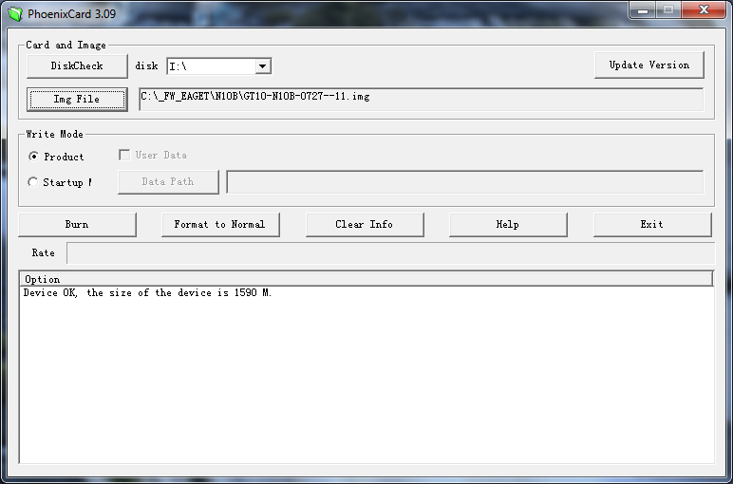
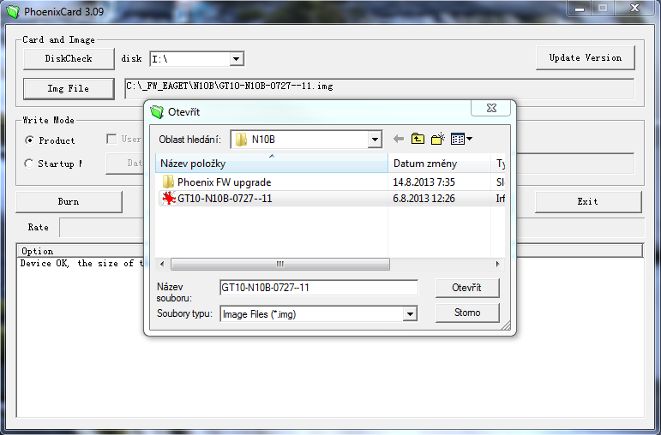

5. Format the the micro SD card
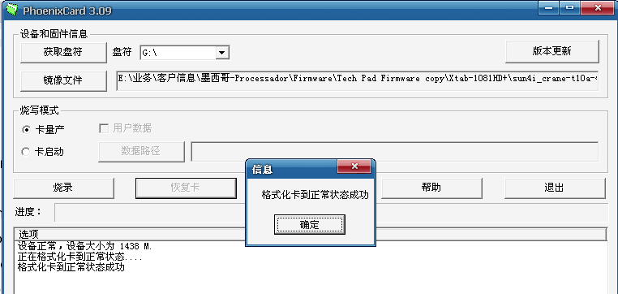

6. Burn the firmware to the micro SD card.
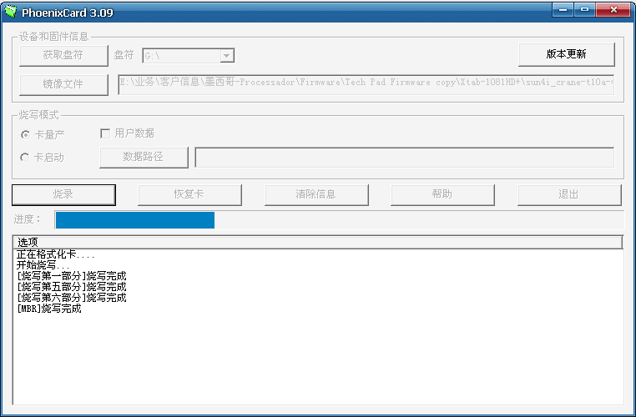
- Finished burning the micro SD card.
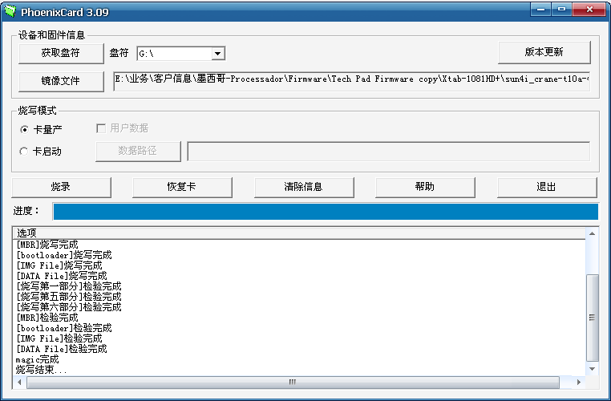
And then upgrade firmware as below steps:
Step 1: make sure the tablet is power off; insert the micro SD card to the card slot.
Step 2: press and hold the power button until the upgrade bar shown on the tablet screen.
Step 3: when the device finish upgrading, remove the micro SD card, and turn on the tablet to check the new system.

